
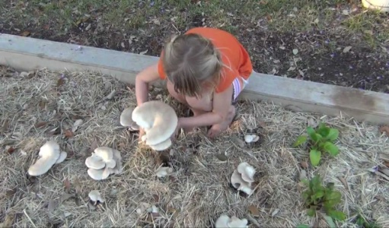
Elm Oyster
(Hypzigus ulmarius)
Common names: Elm or Garden Oyster

A delicious edible mushroom and an amazing garden companion. A natural way to recycle nutrients and grow gourmet mushrooms at the same time. Elm oysters have a nutty flavor and firm texture, but their culinary benefits are just a starting point. This species also has reported beneficial symbiotic relationships with certain vegetable crops - especially brassica species, and grows exceedingly well among kale and broccoli plants. Paul Stamets has reported a 2-fold increase in brassica yields and a 3-fold total food production increase when the vegetables were grown in the same bed as elm oyster mushrooms. They bond with nitrogen fixing bacteria and collaborate with mycorhizal fungi around vegetables and fruit trees.
A great ally for most garden vegetables, this aggressive Garden Oyster mushroom will not attack living plants but unlocks nutrients from straw, sawdust, and organic debris, feeding the roots of underlying plants. Fruits in the spring to early fall.
How to use: This spawn will inoculate an area up to 20 square feet (ie. 1 ft x 20 ft row; or about 5x4 ft bed).The best method to apply this one it to break it up by hand and broadcast into onto a moist mulch (straw, woodchips, garden debris) as one layer- in your raised beds, as a sidedress to your veggie garden, or around your fruit trees and berry bushes. Overlay it with loose straw. The mycelium will grow into the underlayers of the straw as it ages, and into any undecomposed woody or plant material beneath. You can use it as long as ground temperatures are above freezing. This is a cold tolerant species and once established, can overwinter with heavy mulching.
After inoculating your bed, water thoroughly, and water regularly (2-3x week) to make sure it doesn’t dry out.
Mushrooms usually appear as leafy vegetables mature, increasing humidity near the ground, eliciting upward growth as moisture increases beneath the plant- as the leafy veg extends so does the territory for mushrooms- these are bonus crops though, the real benefits come from the nutrients freed for your plants from the decomposing mycelium.
If you want more oyster production than benefit to your garden, you can make a mushroom bed by layering this spawn into a bed of moist hardwood woodchips and straw.

