
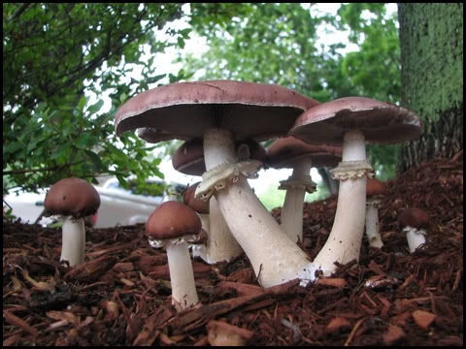
Stropharia rugoso annulata
Common names: King Stropharia, Garden giant, the wine cap
An amazing companion to the garden, King Stropharia breaks down organic matter and woody debris for food and in doing so makes nutrients available to plants, stimulating plant growth and enriching soil. It can thrive amidst bacteria and in disturbed areas and has a wonderful scent which attracts earthworms, and provides medicine for bees and other insects. Friendly to most plants and an especially good companion to corn, rhododendrons, blueberries, potatoes, squash and zucchini. Not to mention it produces giant edible (up to 5 lb) protein-rich mushrooms with burgundy colored caps.
This spawn: Has been grown on fresh alder woodchips, Douglas Fir sawdust and pasteurized straw, outdoors. This strain is therefore well-adapted to the climate here, and to the bacteria and other soil organisms present in this area. It may have soil organisms in the bag- this is a good thing- like a soil-health-booster in a bag! Use this spawn within 6 months of purchase; store out of direct sunlight.
Uses: Great in garden pathways, mushroom beds, or around fruit trees. To make a mushroom bed or pathway, choose a location that isn’t exposed to direct sunlight or mid-day sun. Could be beneath a canopy of trees, shrubs, bushes or leafy vegetables- just avoid areas full of leaves and needles (from conifer trees). The site shouldn’t be too windy and should have high humidity- a north slope, ravine, or depression in which water crosses during rainfall is ideal and ready access to water but won’t be submerged in standing water.
The best time to make a mushroom bed is the spring or fall. You will want to establish your mushroom patch at least 1 month before extreme temperatures (ie- freezing, or summer heat). To make a mushroom bed or pathway:
- This spawn will inoculate an area roughly 4x8x2.” Clear the area, lay down cardboard to prevent native fungi in the soil from competing with the Stropharia. Layer MOIST hardwood-deciduous (alder, oak, maple) woodchips which are fresh as possible about 1-2 inches deep. Avoid cedar and pine and aromatic wood chips as these contain natural anti-fungal compounds. Soak the woodchips overnight in a garbage can to ensure they are moist.
- Broadcast the spawn evenly over the chips. Add another 1-2 inches of woodchips and mix the layers into each other. Water for at least 10 minutes.
- Ensure the patch or pathway doesn’t dry out, nor is exposed to temperature extremes within the first month of growth. Best to establish in the spring or fall when the rains will water it in. Takes 6 months- 1 year to establish. Fruits in late spring through early fall, climaxing in midsummer. Pathways or mushroom bed will last for years if you add more food- i.e. woodchips.

